DOCKER Hands on Lab 01.

----------------------

Deadline:- 09 Jan 2024 till 3:00 PM

1. Docker installation: Install Docker on your local system (Windows, macOS, or Linux). Verify the installation by running the docker --version and docker info commands.

Sol:-

> sudo apt install -y curl

> curl -s https://raw.githubusercontent.com/karaage0703/ubuntu-setup/master/install-docker.sh | /bin/bash

> sudo service docker start

> root@DESKTOP-SQGRBLG:~# service docker start

* Starting Docker: docker [ OK ]

root@DESKTOP-SQGRBLG:~# service docker status

* Docker is running

root@DESKTOP-SQGRBLG:~#

-------------------------------------------------------------------------------------------------------------------------------

2. Working with Docker images: Search for the official Ubuntu image on Docker Hub, pull it to your local system using docker pull, and list all available images on your system using docker images.

Sol:

**Searching Ubuntu Image on docker Hub**

**root@DESKTOP-SQGRBLG:~# docker search ubuntu**

**NAME DESCRIPTION STARS OFFICIAL AUTOMATED**

ubuntu Ubuntu is a Debian-based Linux operating sys… 16754 [OK]

websphere-liberty WebSphere Liberty multi-architecture images … 296 [OK]

open-liberty Open Liberty multi-architecture images based… 62 [OK]

neurodebian NeuroDebian provides neuroscience research s… 105 [OK]

ubuntu-debootstrap DEPRECATED; use "ubuntu" instead 52 [OK]

ubuntu-upstart DEPRECATED, as is Upstart (find other proces… 115 [OK]

ubuntu/nginx Nginx, a high-performance reverse proxy & we… 104

ubuntu/squid Squid is a caching proxy for the Web. Long-t… 74

ubuntu/cortex Cortex provides storage for Prometheus. Long… 4

ubuntu/prometheus Prometheus is a systems and service monitori… 53

ubuntu/apache2 Apache, a secure & extensible open-source HT… 70

ubuntu/kafka Apache Kafka, a distributed event streaming … 37

ubuntu/bind9 BIND 9 is a very flexible, full-featured DNS… 66

ubuntu/mysql MySQL open source fast, stable, multi-thread… 56

ubuntu/zookeeper ZooKeeper maintains configuration informatio… 12

ubuntu/postgres PostgreSQL is an open source object-relation… 32

ubuntu/redis Redis, an open source key-value store. Long-… 21

ubuntu/jre Distroless Java runtime based on Ubuntu. Lon… 12

ubuntu/dotnet-aspnet Chiselled Ubuntu runtime image for ASP.NET a… 15

ubuntu/grafana Grafana, a feature rich metrics dashboard & … 9

ubuntu/memcached Memcached, in-memory keyvalue store for smal… 5

ubuntu/dotnet-deps Chiselled Ubuntu for self-contained .NET & A… 11

ubuntu/prometheus-alertmanager Alertmanager handles client alerts from Prom… 9

ubuntu/dotnet-runtime Chiselled Ubuntu runtime image for .NET apps… 13

ubuntu/cassandra Cassandra, an open source NoSQL distributed … 2

root@DESKTOP-SQGRBLG:~#

**Pulling Docker Hub into local System**

**root@DESKTOP-SQGRBLG:~# docker pull ubuntu**

Using default tag: latest

latest: Pulling from library/ubuntu

a48641193673: Pull complete

Digest: sha256:6042500cf4b44023ea1894effe7890666b0c5c7871ed83a97c36c76ae560bb9b

Status: Downloaded newer image for ubuntu:latest

docker.io/library/ubuntu:latest

root@DESKTOP-SQGRBLG:~#

**root@DESKTOP-SQGRBLG:~# docker pull ubuntu:20.04**

20.04: Pulling from library/ubuntu

527f5363b98e: Pull complete

Digest: sha256:f2034e7195f61334e6caff6ecf2e965f92d11e888309065da85ff50c617732b8

Status: Downloaded newer image for ubuntu:20.04

docker.io/library/ubuntu:20.04

**Listing all available images**

root@DESKTOP-SQGRBLG:~# **docker images**

REPOSITORY TAG IMAGE ID CREATED SIZE

ubuntu 20.04 f78909c2b360 3 weeks ago 72.8MB

ubuntu latest 174c8c134b2a 3 weeks ago 77.9MB

root@DESKTOP-SQGRBLG:~#

-------------------------------------------------------------------------------------------------------------------------------

3. Creating a Docker container: Run a Docker container using the Ubuntu image, and execute a command inside the container (e.g., echo "Hello, Docker!").

**Sol: -**

**root@DESKTOP-SQGRBLG:~# docker container create ubuntu**

103fb8836ea3abb321d553fec25a66e279aefdeaf5ffd38fbcb400f8bbd0ab5d

root@DESKTOP-SQGRBLG:~# cd /var/lib/docker/

root@DESKTOP-SQGRBLG:~# **docker run -it ubuntu:20.04**

**root@fb6758c1acb2:/# echo "Practicing Docker!"**

**Practicing Docker!**

root@8fd28d8f5a54:/#

root@8fd28d8f5a54:/#

root@8fd28d8f5a54:/# exit

**exit**

-------------------------------------------------------------------------------------------------------------------------------

4. Inspect the Ubuntu Docker container to ensure it is in the "created" state only.

root@DESKTOP-SQGRBLG:~# docker container ls -a



-------------------------------------------------------------------------------------------------------------------------------

5. Execute the Ubuntu Docker container and confirm that the container's state is "running."

root@DESKTOP-SQGRBLG:~# docker ps -a

CONTAINER ID IMAGE COMMAND CREATED STATUS PORTS NAMES

ccfaa7c7fbc5 ubuntu "/bin/bash" 2 minutes ago Exited (0) 2 minutes ago adoring_williamson

root@DESKTOP-SQGRBLG:~# docker ps -a

CONTAINER ID IMAGE COMMAND CREATED STATUS PORTS NAMES

ccfaa7c7fbc5 ubuntu "/bin/bash" 2 minutes ago Exited (0) 2 minutes ago adoring_williamson

root@DESKTOP-SQGRBLG:~# docker inspect my-ubuntu-container

[

{

"Id": "7b2abddc9fd9ee9b52f3926ca231c1a3e5e1a3db4fe489b86a3627ba5351e268",

"Created": "2024-01-09T10:36:12.9753619Z",

"Path": "/bin/bash",

"Args": [],

"State": {

"Status": "exited",

"Running": false,

"Paused": false,

"Restarting": false,

"OOMKilled": false,

"Dead": false,

"Pid": 0,

"ExitCode": 127,

"Error": "",

-------------------------------------------------------------------------------------------------------------------------------

6. Launch an HTTP container, verify its state, and then remove the container and image from your local system.

root@DESKTOP-SQGRBLG:~# docker pull httpd

Using default tag: latest

latest: Pulling from library/httpd

Digest: sha256:f0a93744d8006e6f7ee5086c9ddccdcfa33d1091f15269a00547b4c382459c1f

Status: Image is up to date for httpd:latest

docker.io/library/httpd:latest

root@DESKTOP-SQGRBLG:~#

root@DESKTOP-SQGRBLG:~# docker ps -a

CONTAINER ID IMAGE COMMAND CREATED STATUS PORTS NAMES

661262c7fa44 httpd "httpd-foreground" 3 minutes ago Created relaxed_lehmann

59341a902dd0 ubuntu "/bin/bash" 2 hours ago Exited (0) 2 hours ago angry_allen

1932ad728656 httpd "httpd-foreground" 2 hours ago Created sad_black

ccfaa7c7fbc5 ubuntu "/bin/bash" 2 hours ago Exited (0) 2 hours ago adoring_williamson

fa1861c526f1 ubuntu "/bin/bash" 3 hours ago Exited (0) 3 hours ago youthful_brown

7b2abddc9fd9 ubuntu "/bin/bash" 3 hours ago Exited (127) 3 hours ago my-ubuntu-container

0320194b5e8c ubuntu "/bin/bash" 3 hours ago Exited (0) 3 hours ago pedantic_hofstadter

d9b643c59500 ubuntu "echo 'Hello, Docker…" 3 hours ago Exited (0) 3 hours ago happy_curran

647b8a5c60e5 ubuntu "/bin/bash" 3 hours ago Exited (0) 3 hours ago quizzical_bell

3c0d14e42bc8 ubuntu "/bin/bash" 3 hours ago Exited (0) 3 hours ago blissful_nobel

3ce4df3f64ed ubuntu "-it /bin/bash" 3 hours ago Created strange_chatelet

424cf518800a ubuntu "/bin/bash" 3 hours ago Exited (0) 3 hours ago magical_hawking

fb6758c1acb2 ubuntu:20.04 "/bin/bash" 3 hours ago Exited (0) 3 hours ago compassionate_cori

8fd28d8f5a54 ubuntu:20.04 "/bin/bash" 3 hours ago Exited (127) 3 hours ago optimistic_gates

b76ef1fbad43 ubuntu "/bin/bash" 4 hours ago Created confident_archimedes

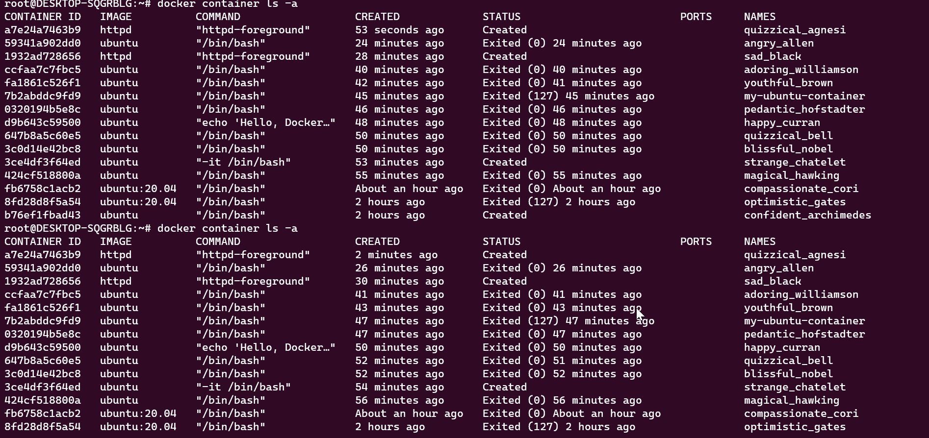

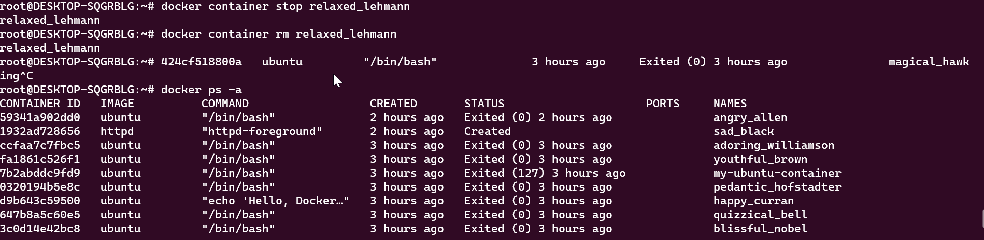

-------------------------------------------------------------------------------------------------------------------------------

7. Execute a command to display a filtered list of containers, showing only their short container IDs.

root@DESKTOP-SQGRBLG:~# docker ps -aq

59341a902dd0

1932ad728656

ccfaa7c7fbc5

fa1861c526f1

7b2abddc9fd9

0320194b5e8c

d9b643c59500

647b8a5c60e5

3c0d14e42bc8

3ce4df3f64ed

424cf518800a

fb6758c1acb2

8fd28d8f5a54

b76ef1fbad43

root@DESKTOP-SQGRBLG:~#

-------------------------------------------------------------------------------------------------------------------------------